Weather Data simulation Installation

## JAVA Installation

Install java/JRE on your computer if it isn't installed. We can't run JAR files without Java/JRE installed. If you don't already have Java installed, go to Java's website at <https://docs.oracle.com/javase/8/docs/technotes/guides/install/install_overview.html>

## Maven Installation

Install Maven on your computer if it isn’t installed

<https://maven.apache.org/install.html>

## GitHub

1. Project repository location

https://github.com/srawanthi/weather-simulator.git

1. Open in Web Browser e.g Internet Explorer/Chrome etc.,

And click on clone or download in Webpage

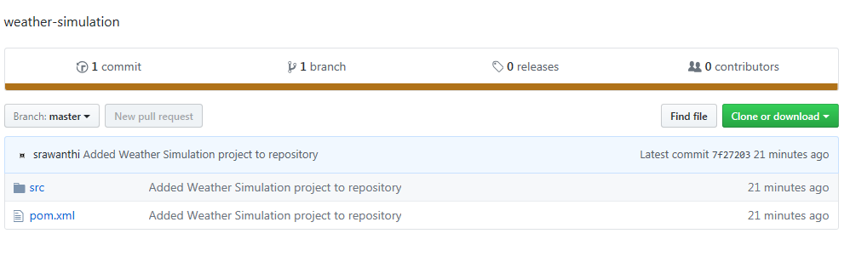

1. Click on Download zip button

Save zip file in File Explorer

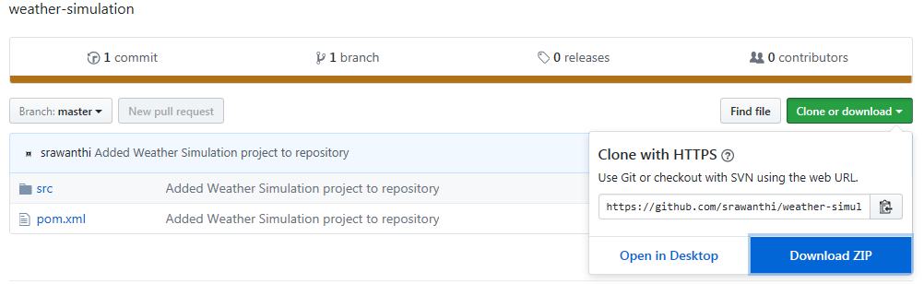

1. Extract zip file to local machine as:

<Folder Location>\ weather-simulator-master

My folder Location : D:\Projects\Srawanthi\poc\TCS (which I will refer this location throughout the document)

e.g. D:\Projects\Srawanthi\poc\TCS\weather-simulator-master

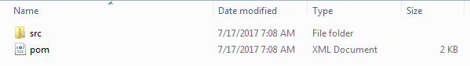

## Project Running Steps

1. Make a pre-note Java/JRE, Maven are installed and configured paths in Environment Variables.
2. Check the Java version

$> java -version

java version "1.8.0_131"

Java(TM) SE Runtime Environment (build 1.8.0_131-b11)

Java HotSpot(TM) 64-Bit Server VM (build 25.131-b11, mixed mode)

1. Check the maven version

$>mvn –v

Apache Maven 3.3.9 (bb52d8502b132ec0a5a3f4c09453c07478323dc5; 2015-11-10T22:11:47+05:30)

Maven home: D:\ProgramFiles\automatic\apache-maven-3.3.9\bin\..

Java version: 1.8.0_91, vendor: Oracle Corporation

Java home: D:\ProgramFiles\automatic\Java\jdk1.8.0_91\jre

Default locale: en_US, platform encoding: Cp1252

OS name: "windows 7", version: "6.1", arch: "amd64", family: "dos"

1. Go to Project Location from command

$>cd <project location>

Project location: which we download or extract from GitHub Repository

e.g:>cd D:\Projects\Srawanthi\poc\TCS\weather-simulator-master

weather-simulator-master is root folder contains pom.xml, src folder

1. Run the below command to generate the jar file in target folder

$>mvn clean install

D:\Projects\Srawanthi\poc\TCS\weather-simulator-master>mvn clean install

[INFO] Scanning for projects...

[INFO]

[INFO] ------------------------------------------------------------------------

[INFO] Building WeatherSimulator 0.0.1-SNAPSHOT

[INFO] ------------------------------------------------------------------------

[INFO]

[INFO] --- maven-clean-plugin:2.5:clean (default-clean) @ weather-simulator ---

[INFO]

[INFO] --- jacoco-maven-plugin:0.7.5.201505241946:prepare-agent (default-prepare-agent) @ weather-simulator ---

[INFO] argLine set to -javaagent:C:\\Users\\srawanthi.samala\\.m2\\repository\\org\\jacoco\\org.jacoco.agent\\0.7.5.201505241946\\org.jacoco.agent-0.7.5.201505241946-runtime.jar=destfile=D:\\Projects\\Srawanthi\\poc\\TCS\\weather-simulator-master

[INFO]

[INFO] --- maven-resources-plugin:2.6:resources (default-resources) @ weather-simulator ---

[INFO] Using 'UTF-8' encoding to copy filtered resources.

[INFO] Copying 3 resources

[INFO]

[INFO] --- maven-compiler-plugin:3.2:compile (default-compile) @ weather-simulator ---

[INFO] Changes detected - recompiling the module!

[INFO] Compiling 8 source files to D:\Projects\Srawanthi\poc\TCS\weather-simulator-master\target\classes

[INFO]

[INFO] --- maven-resources-plugin:2.6:testResources (default-testResources) @ weather-simulator ---

[INFO] Using 'UTF-8' encoding to copy filtered resources.

[INFO] skip non existing resourceDirectory D:\Projects\Srawanthi\poc\TCS\weather-simulator-master\src\test\resources

[INFO]

[INFO] --- maven-compiler-plugin:3.2:testCompile (default-testCompile) @ weather-simulator ---

[INFO] Changes detected - recompiling the module!

[INFO] Compiling 2 source files to D:\Projects\Srawanthi\poc\TCS\weather-simulator-master\target\test-classes

[INFO]

[INFO] --- maven-surefire-plugin:2.12.4:test (default-test) @ weather-simulator ---

[INFO] Surefire report directory: D:\Projects\Srawanthi\poc\TCS\weather-simulator-master\target\surefire-reports

-------------------------------------------------------

T E S T S

-------------------------------------------------------

Running com.tcs.weather.TestWeatherDataUtils

Tests run: 3, Failures: 0, Errors: 0, Skipped: 0, Time elapsed: 0.1 sec

Running com.tcs.weather.TestWeatherSimulator

Weather Simulator Parameters

city [e.g. Sydney]

country [e.g. Australia]

datewithtime YYYY-MM-DD HH:mm:ss [e.g. 2017-07-20 16:02:12]

worldcitiescoordinatorslistpath [ e.g. src/main/resources/longlatlookup-place-timezone.txt ]

weatherhistoricalyearwisedataPath [ e.g. src/main/resources/2017-07-14-weatherdata.txt ]

city Sydney position -33.86785,151.2073212,1 Locationtimeutc 2017-01-14temparature 25.5 humidity 62.5 pressure 1004.0 conditions Rain

Tests run: 2, Failures: 0, Errors: 0, Skipped: 0, Time elapsed: 1.496 sec

Results :

Tests run: 5, Failures: 0, Errors: 0, Skipped: 0

[INFO]

[INFO] --- jacoco-maven-plugin:0.7.5.201505241946:report (default-report) @ weather-simulator ---

[INFO] Analyzed bundle 'WeatherSimulator' with 7 classes

[INFO]

[INFO] --- maven-jar-plugin:2.4:jar (default-jar) @ weather-simulator ---

[INFO] Building jar: D:\Projects\Srawanthi\poc\TCS\weather-simulator-master\target\weather-simulator-0.0.1-SNAPSHOT.jar

[INFO]

[INFO] --- maven-install-plugin:2.4:install (default-install) @ weather-simulator ---

[INFO] Installing D:\Projects\Srawanthi\poc\TCS\weather-simulator-master\target\weather-simulator-0.0.1-SNAPSHOT.jar to C:\Users\srawanthi.samala\.m2\repository\com\tcs\weather\weather-simulator\0.0.1-SNAPSHOT\weather-simulator-0.0.1-SNAPSHOT.jar

[INFO] Installing D:\Projects\Srawanthi\poc\TCS\weather-simulator-master\pom.xml to C:\Users\srawanthi.samala\.m2\repository\com\tcs\weather\weather-simulator\0.0.1-SNAPSHOT\weather-simulator-0.0.1-SNAPSHOT.pom

[INFO] ------------------------------------------------------------------------

[INFO] BUILD SUCCESS

[INFO] ------------------------------------------------------------------------

[INFO] Total time: 7.234 s

[INFO] Finished at: 2017-07-20T01:21:38+05:30

[INFO] Final Memory: 24M/194M

[INFO] ------------------------------------------------------------------------

D:\Projects\Srawanthi\poc\TCS\weather-simulation-master>

1. Jar file is created in target folder.

[INFO] Building jar: D:\Projects\Srawanthi\poc\TCS\weather-simulator-master\target\weather-simulator-0.0.1-SNAPSHOT.jar

1. Go to target folder

$> cd D:\Projects\Srawanthi\poc\TCS\weather-simulator-master\target

Run the jar file

java -cp <jarfile> <classname with package> city country datewithtime worldcitiescoordinatorslistpath weatherhistoricalyearwisedataPath

Ex1)

java -cp weather-simulator-0.0.1-SNAPSHOT.jar com.tcs.weather.WeatherGameSimulator Sydney Australia 2015-12-23T16:02:12Z D:\Projects\Srawanthi\poc\TCS\weather-simulator-master\src\main\resources\World_Cities_Coordinators.txt D:\Projects\Srawanthi\poc\TCS\weather-simulator-master\src\main\resources\threelocations_365days_hystoricaldata.txt

Output::

City: Sydney Position -33.86785,151.2073212,1 Locationtime: 2015-12-23T16:02:12Z temparature 22.5 Humidity: 56.0 Pressure: 1016.5 Conditions: Sunny

e.g.,2)

java -cp weather-simulator-0.0.1-SNAPSHOT.jar com.tcs.weather.WeatherGameSimulator Sydney Australia 2018-3-23 D:\Projects\Srawanthi\poc\TCS\weather-simulator-master\src\main\resources\World_Cities_Coordinators.txt D:\Projects\Srawanthi\poc\TCS\weather-simulator-master\src\main\resources\threelocations_365days_hystoricaldata.txt

output:

City: Sydney Position -33.86785,151.2073212,1 Locationtime: 2018-3-23 temparature 20.0 Humidity: 87.5 Pressure: 1017.0 Conditions: Rain

1. Test case Report generator

Go to target folder contains site folder

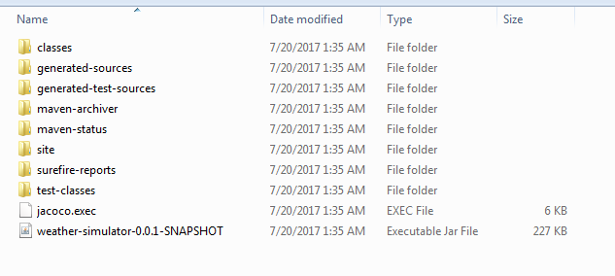

site folder contains jacoco test case report 🡪 target/site/jacoco/index.html

open D:/Projects/Srawanthi/poc/TCS/weather-simulator-master/target/site/jacoco/index.html in browser

